**Union All transformation in IICS .**

Union All : The Union transformation is an active transformation that we use to merge data from multiple inputs into a single output. For data integration patterns, it is common to combine two or more data sources into a single stream that includes the union of all rows.

Union all start with the following steps

1. Making a source connection with two to three sources
2. Then connecting these sources to union Transformation
3. Target connection

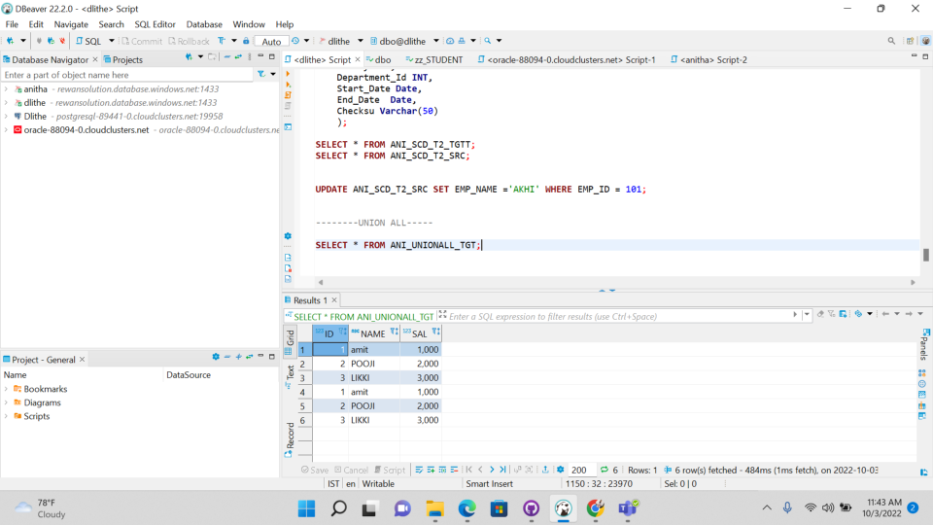**FINAL OUTPUT OF UNION ALL**

In the evening session there was presentation for other teams, and it was great information and recap they done about the reports topic.